MATERIAL INSPECTION LOT MODULE:

1. MATERIAL INPSECTION LOT ENTITY : IN MATERIAL INPSECTION LOT WE HAVE MATERIAL(MANY MATERIALS TO ONE), VENDOR(MANY TO ONE), MATERIAL ACTUALS(ONE TO MANY ),PLANT(MANY TO ONE) ETC…PROPERTIES ----------->{CARDINAL RELATIONS}.

NOTE : AND ON THE OTHER SIDE OF THE RELATED ENTITIES CARDINAL RELATIONS HAS TO BE MAINTAINED. LIKE THIS DO FOR THE REMAINING ASSOSCIATED CLASSES OK.

AFTER CREATING THE TABLES. SAVING OF THE RECORD IS REQUIRED.WHILE SAVING THESE VARIABLES I AM SAVING INTO THE DB. THEY ARE…

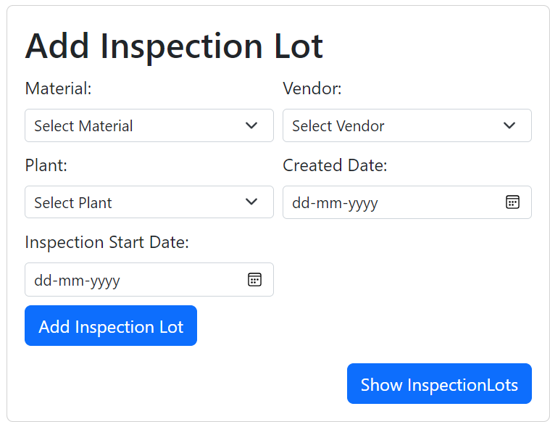

NOTE : YOU TAKE ABOUT THE CONTROLER, SERVICE AND REPO LAYER

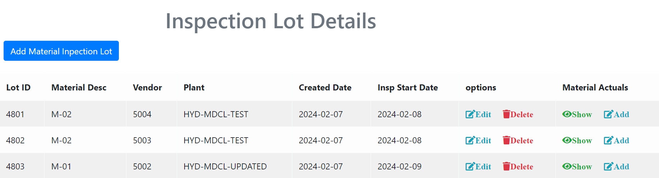

SHOWING OF THE MATERIAL INSPECTION LOT AND HOW I AM GOING TO USE THE FUNCTIONALITIES FROM HERE. BY USING FINDALL METHOD OF MATERIAL INSPECTION LOT REPO. HIBERNATE WILL FETCH THE RECORD OF MATERIAL INSPECTION LOT OBJECT AND ALSO THE ASSOSCIATED OBJECT RECORDS.

EXAMPLE:

MATERIAL INSPECTION LOT OBJECT CONTAINS ASSOSCIATED PLANT, VENDOR, MATERIAL AND MATERIAL CONTAINS THE MATERIAL CHARACTERISTICS OBJECT.

THIS IS THE SIMPLE OVER VIEW OF THE MATERIAL INSPECTION LOT. HOPE THIS HELPS A LITTLE.